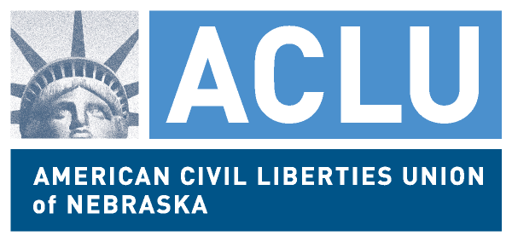
941 O St. #706, Lincoln NE 68508
www.aclunebraska.org
FOR IMMEDIATE RELEASE
March 13, 2012
CONTACT: Amy Miller, (402) 476-8091, info@aclunebraska.org
Civil Rights and Community Organizations Request DOJ to Investigate Omaha Police
LINCOLN - On March 13, ACLU Nebraska along with other civil rights and community-based organizations are requesting that the Civil Rights Division of the Department of Justice conduct a federal review of police practices in Omaha. A letter seeking the investigation was sent to Justice Department officials in Washington, DC and Omaha on March 13.
The ACLU and its allies are seeking an investigation under the federal Violent Crime Control and Law Enforcement Act of 1994. The Department of Justice’s website explains that the statute “prohibits law enforcement agencies from regularly violating existing constitutional protections against police misconduct, such as excessive force, false arrests, unreasonable searches or seizures, and intentional racial or ethnic discrimination.”
ACLU Nebraska Legal Director Amy Miller released the following statement:
“Along with the other organizations signing onto the letter, our office has received a number of complaints from Omaha residents who have interacted with law enforcement. These complaints undermine the trust law enforcement has from the people of Omaha that expect to be treated fairly and kept safe. The Department of Justice’s role is to review police practices along with individual complaints and build the trust Omaha residents have in their law enforcement.”
“It is necessary to bring in the DOJ because the city of Omaha has failed to police itself. The city refused to follow its own law by hiring a new Public Safety Auditor, despite our 2008 lawsuit Parks v City of Omaha. The city failed to respond to allegations of evidence planting in 2010. Additional public outcries, such as the one over the alleged beating of Omaha resident Robert Wager last year have received little response. Without clear action from OPD to assure the public that practices and allegations are being reviewed, we need the DOJ to provide the investigations that we cannot trust are happening through OPD.”
###
ABOUT: ACLU Nebraska and its diverse membership works in courts, the legislature and our communities to defend and preserve the individual rights and liberties that the Constitution and laws of the United States and Nebraska guarantee everyone in this state.

